

Assessment Cover Page
Student Full Name
Alexsander de Sousa Nelson
Student Number
2026509
Module Title
Strategic Thinking
Assessment Title
CA 1 – Capstone Project Proposal
Lecturer/Supervisor
Taufique Ahmed
Assessment Due Date
25/10/2026
Date of Submission
23/10/2026
Use of AI Tools
I acknowledge the use of Chat GPT (OpenAI) to help understand the assessment requirements, exploring and refining the project topic, proposal structure,
Declaration
By submitting this assessment, I confirm that I have read the CCT policy on academic misconduct and understand the implications of submitting work that is not my own or does not appropriately reference material taken from a third party or other source.
I declare it to be my own work and that all material from third parties has been appropriately referenced.
I further confirm that this work has not previously been submitted for assessment by myself or someone else in CCT College Dublin or any other higher education institution.

Contents

- Introduction 1
- Problem Definition 1
- Aim and Objectives 1
- Scope 1
- Methodology 1
- Data Sources 1
- Expected Deliverables 1
- Project Timeline 1
- Ethical and Legal Considerations 1
- References 1
- Appendix 1

Link on GitHub: 2026509-cpu/Strategic-Thinking

Project Title

Predicting Bike Stock-Outs at DublinBikes Stations

Introduction

DublinBikes is a bicycle-sharing system that operates at different locations throughout the city of Dublin. The service allows registered users to pick up a bicycle at one station and return it to any other station in the system, meaning that they do not need to return it to the same location where they collected it. The number of bicycles available at each station changes throughout the day, depending on how many bicycles are collected and returned by users. As a result, someone may arrive at a station and find no bicycles available, or find a station where all docking spaces are occupied by bicycles ready to be collected. Focusing on the problem of users arriving at a station and finding no bicycles available, this project proposes using historical data from DublinBikes stations, together with Machine Learning techniques, to investigate whether bicycle shortages can be predicted in advance.
More specifically, the aim is to predict whether a station will have no bicycles available 30 minutes after a given observation time, or whether at least one bicycle will still be available. The predictions will then be evaluated to determine whether they could help monitor station availability and support operational decision-making.

Problem Definition

Looking at the problem as a whole, one of the operational challenges of bicycle-sharing systems with fixed stations is maintaining a sufficient number of bicycles available throughout the day. If a user arrives at a station and finds no bicycles available, they cannot use the bicycle-sharing service from that location until another user returns a bicycle. By analysing station availability data, it may be possible to identify patterns that could help predict when these situations are likely to occur and potentially help prevent them.
Therefore, the business problem addressed in this project is to identify, in advance, which stations are at risk of running out of bicycles within a short period of time. Using a dataset obtained from the data.gov.ie website, the project will evaluate classification models capable of predicting whether a station will run out of bicycles within a 30-minute period. It is important to note that the proposed system is not intended to replace human decision-making. Its purpose is to provide information that can support operational decisions rather than make them automatically.

Aim and Objectives

3.1 Aim
The aim of this project is to develop and evaluate a Machine Learning model capable of predicting, 30 minutes in advance, whether a DublinBikes station will have no bicycles available. The project will use historical station-status data, including the number of available bicycles, available docking spaces, station capacity and time-related information. The study will also assess the potential of these predictions to support operational decision-making.

3.2 Objectives
- To analyse historical DublinBikes station data and identify temporal and station-level patterns associated with bicycle availability and stock-outs.
- To clean and preprocess the dataset and create a binary target indicating whether a station will have zero bicycles available 30 minutes later.
- To develop relevant availability and time-based features for predictive modelling while avoiding data leakage.
- To develop and compare suitable classification models, including Logistic Regression, Decision Tree and Random Forest.
- To evaluate the models using appropriate classification metrics and interpret the results from an operational and business perspective.

From a business perspective, the objective is to support the earlier identification of stations at greater risk of running out of bicycles, providing information that could assist station-availability monitoring and operational planning.

Scope

The project will initially use data from March 2026 on the status of DublinBikes stations, published by Dublin City Council. The work will include data cleaning and preparation, Exploratory Data Analysis (EDA), the creation of the target variable, feature engineering, and the evaluation of the results. The algorithms initially considered for this project are Logistic Regression, Decision Tree, and Random Forest.
As previously mentioned, the main focus will be on predicting bicycle shortages within a short period of time. Therefore, the project does not aim to develop a complete bicycle redistribution system or a route optimisation system. Real-time implementation, the prediction of individual user behaviour, weather conditions, and automated operational decision-making are also outside the initial scope of the project.

Methodology

Data Sources

Expected Deliverables

Project Timeline

Ethical and Legal Considerations

10. References

11. Appendix

11.1 Understanding the Assessment Requirements
‘’ Chat, I need some help with a college project—Strategic Thinking. I’m a bit lost and would like to better understand the requirements for this assignment. I don't want any information beyond what I ask for, as the use of AI at work is limited.’’
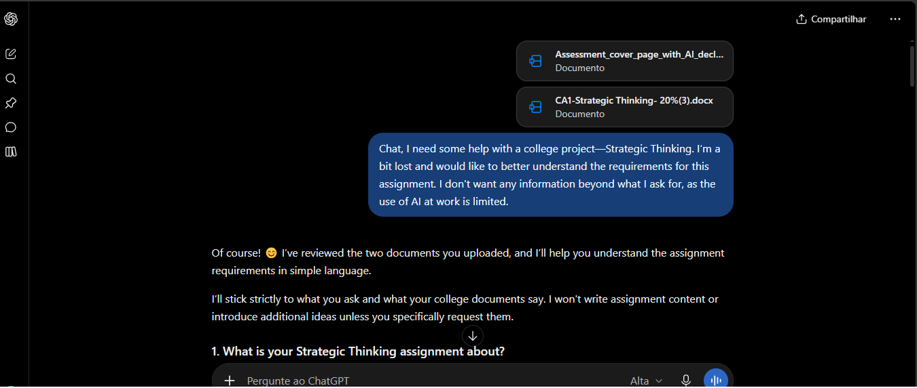

  - Exploring and Refining the Project Topic
‘’ When I arrived in Ireland, I had a lot of trouble finding available bicycles at the bike-sharing stations; because of this, I decided to address the issue of bike shortages at Dublin Bikes stations. The topic could be: "Dublin Bikes – Bike stock-out at stations." What do you think?’’
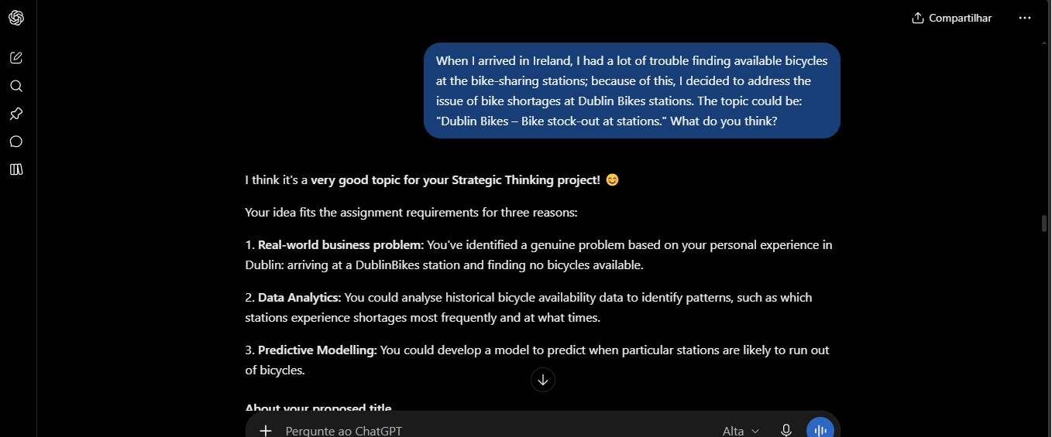

  - Proposal Structure
‘’ The initial idea would be something like trying to predict, 30 minutes in advance, whether a station will run out of bikes or whether it will have at least one bike available. What do you think? Do you believe this idea could work? I found this dataset related to Dublin Bikes at data.gov.ie/dataset/dublinbikes-api.’’
